Chapter 3, Problem 88.

Determine the gain v_{o}/v_{s} of the transistor amplifier circuit in Fig. 3.124.

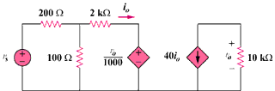

Figure 3.124
For Prob. 3.88.

